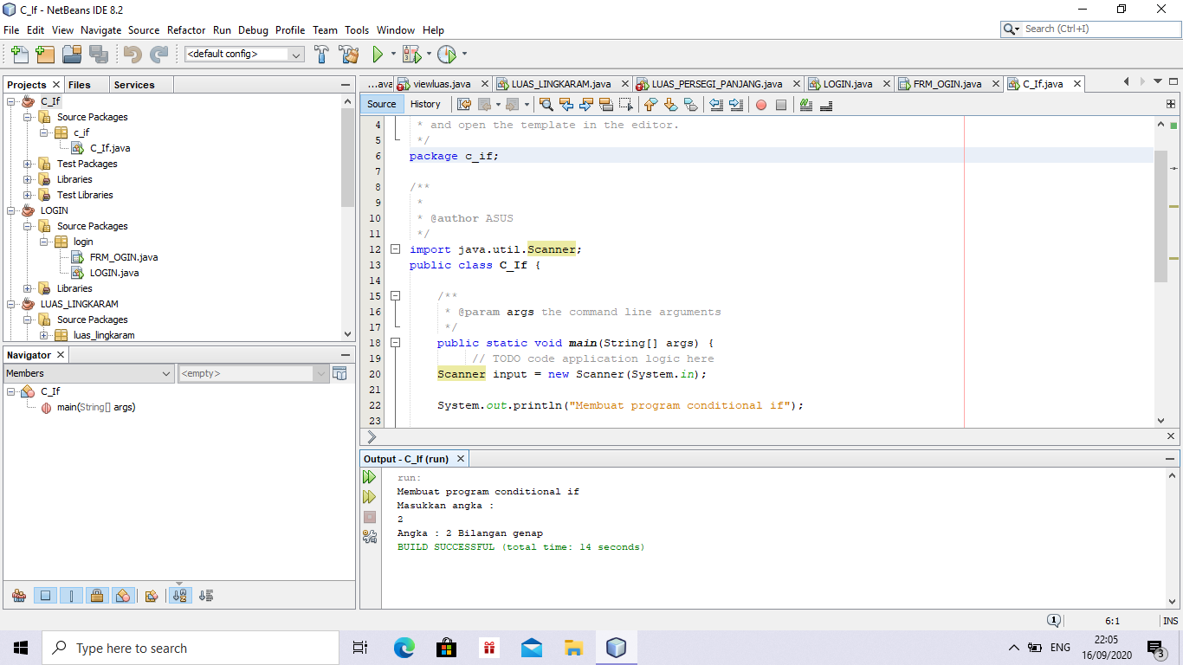ANEDA OCTAVIA SALSA BILLA/02/XI RPL-1

LAPORAN TUGAS PBO

